Knitted Sheep Pattern

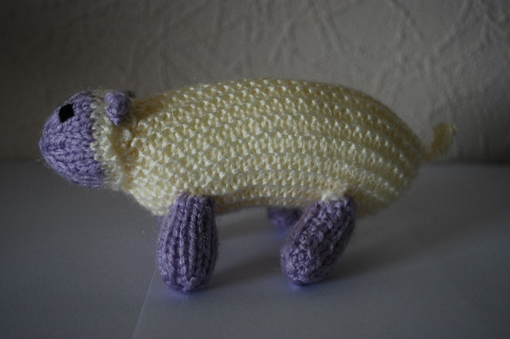
Materials
New washable double knitting yarn: approximately 8g cream colour and 4g grey colour. Please avoid mohair style yarns with fibres that pull off.

3mm knitting needles (UK size 11)

New polyester filling conforming to BS1425 (for cleanliness) and BS5852 (for flammability).

Black Wool or embroidery thread

Tension
26st and 36 rows to 10cm over stocking stitch on 3mm needles
While the finished size is not important, the stitches should be close together so that when the toy is stuffed, the filling does not come out through gaps in the stitches.

Abbreviations
T&D: break yarn leaving a long end, thread through stiches on the needs, draw up tightly and secure.
K2tog: Knit 2 stitches together
P2tog: Purl 2 stitches together

Instructions
Body (make one)
With cream yarn, cast on 15 stitches and knit 2 rows.
Next row: increase in every stitch (30 sts).
Knit 37 rows
Next row: (K2 tog) to end (15 sts)
Knit 1 row.
Cast off.

Head (make one)
With cream yarn, cast on 14 stitches and knit 2 rows.
Next row: increase in every stitch (28 sts)
Knit 4 rows.
Change to grey yarn and purl 1 row.
Next row: (K2 K2tog) to end (21 sts)
Purl 1 row.
Next row: (K1 K2tog) to end (14 sts)
Purl 1 row.
Next row: (K2tog) to end (7 sts).
T&D.

Legs (make four)
With grey yarn, cast on 10 stitches and work 9 rows in stocking stitch (one row knit and one row purl).
Next row: (P2tog) to end (5 sts)
T&D

Ears (make two)
With grey yarn, cast on 4 stitches.
Cast off.

Tail (make one)
With cream yarn, cast on 6 stitches.
Cast off.

To make up:
Fold body in half and stitch, joining the cast on and cast off edges and one end of the body.
Stuff firmly, then join the opening.
Join the head seam, leaving the cast on edge open. Stuff firmly, position and sew onto body.
Join the leg seams, leaving cast on edges open. Stuff firmly, then sew in place.
Sew ears to the side of the head and embroider eyes with black yarn.
Attach tail to the back of the sheep.

